**Practical 5**

**Name:Tanisha Agrawal**

**Roll No:A 13**

**Aim: Install cloud analyst on NetBeans, execute load balancing**

**algorithm. Implement your own algorithm also.**

1) Download cloudAnalyst

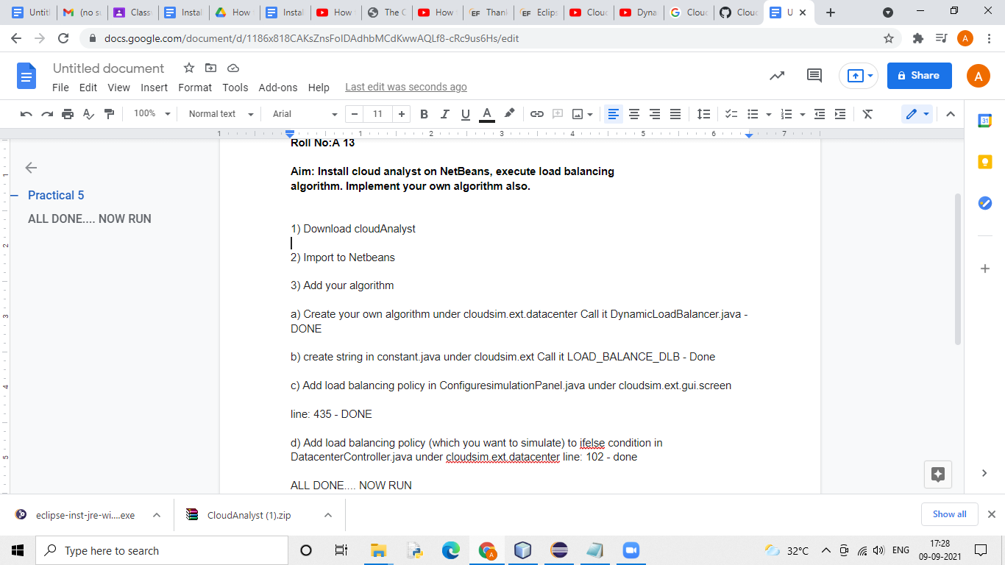

**Downloaded cloudanalyst**

2) Import to Netbeans

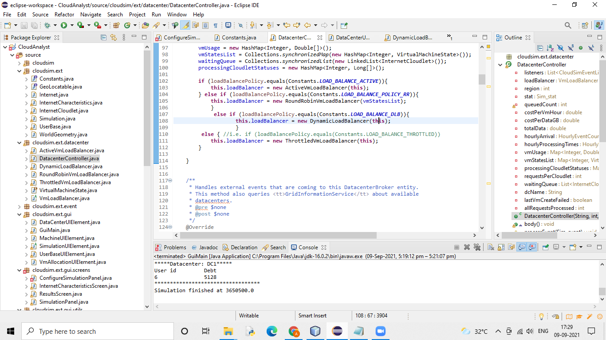

**Imported**

3) Add your algorithm

a) Create your own algorithm under cloudsim.ext.datacenter Call it DynamicLoadBalancer.java

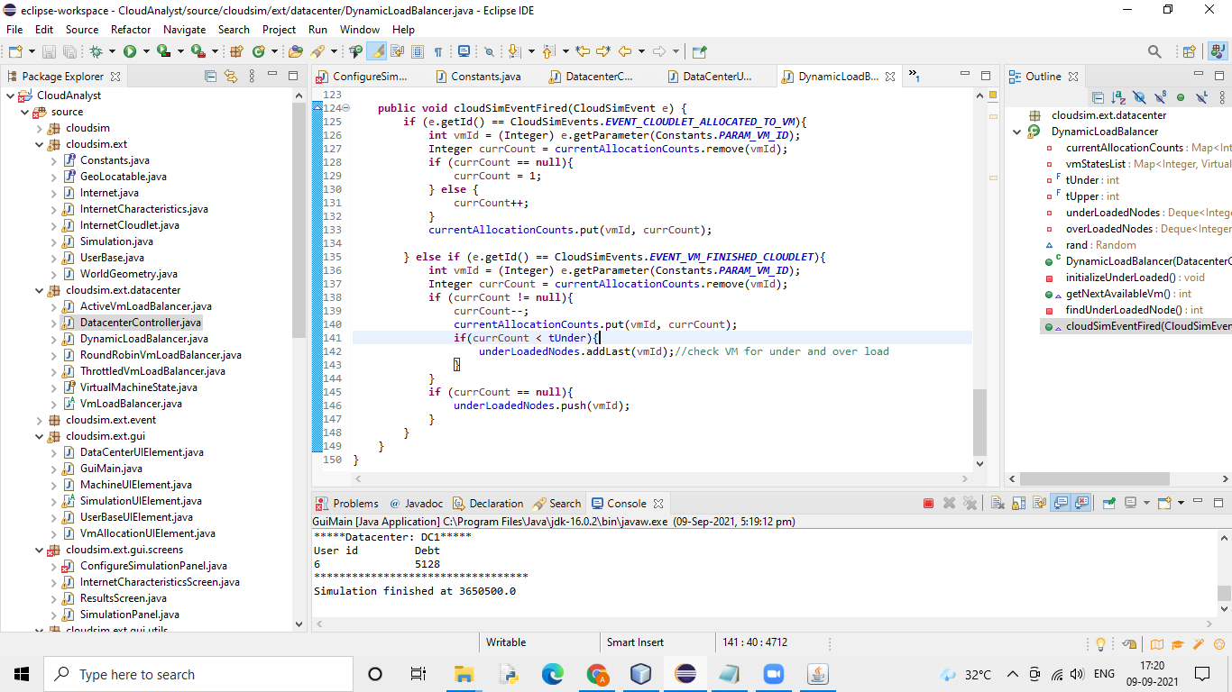

**Added threshold load balancing algorithm with name DynamicLoadBalancer**

b) create string in constant.java under cloudsim.ext Call it LOAD_BALANCE_DLB

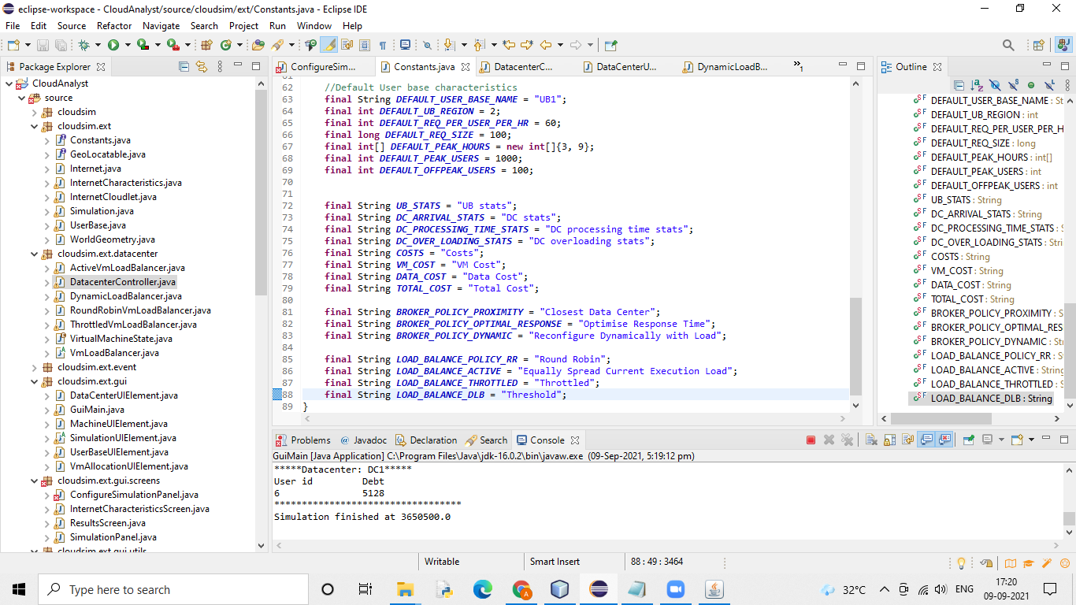

**Added the policy name and named the string as Threshold**

c) Add load balancing policy in ConfiguresimulationPanel.java under cloudsim.ext.gui.screen

line: 435

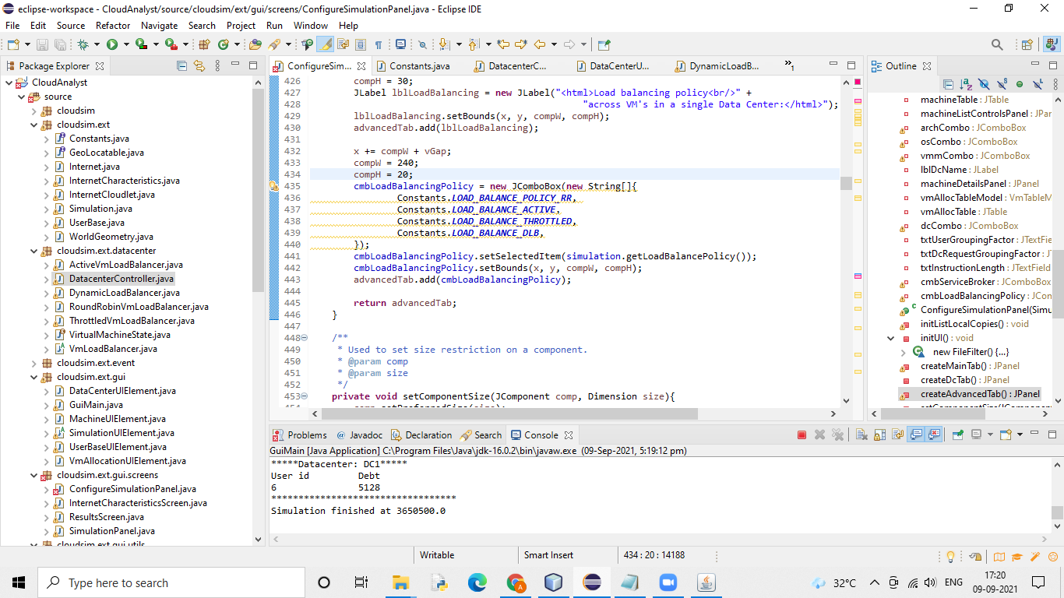

**Added the policy name in ConfiguresimulationPanel.java**

d) Add load balancing policy (which you want to simulate) to if else condition in DatacenterController.java under cloudsim.ext.datacenter line: 102

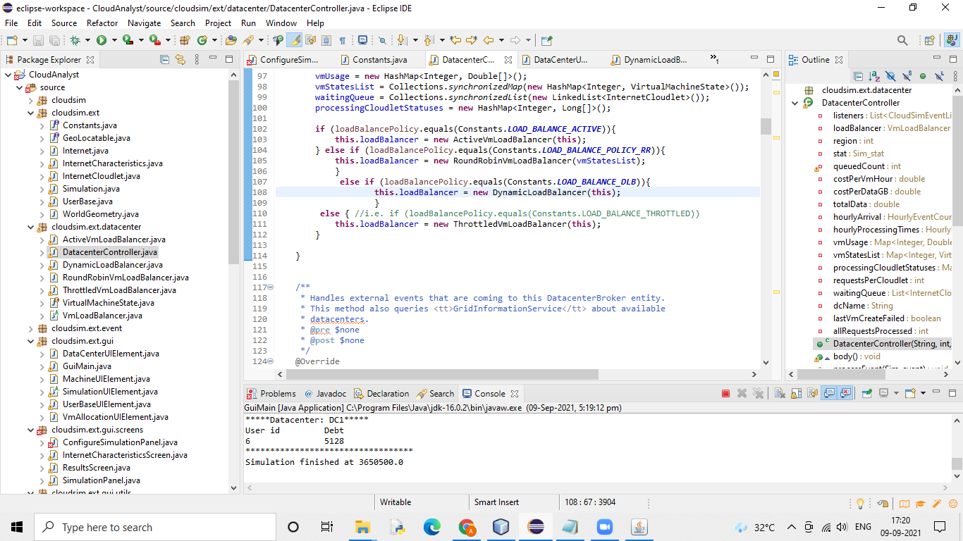

**Added policy in cloudsim.ext.datacenter**

ALL DONE.... NOW RUN

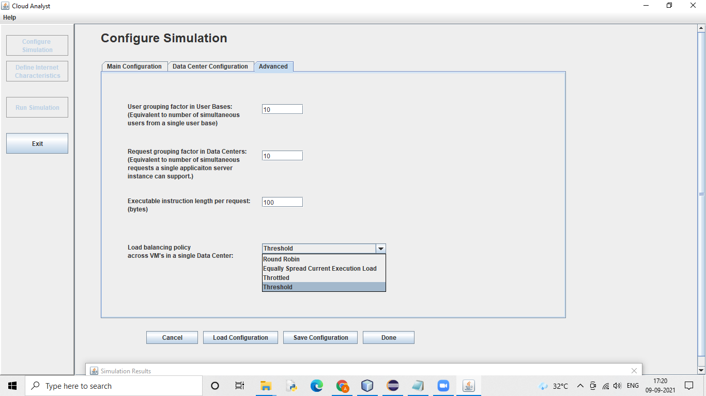

**We can see Threshold is added**

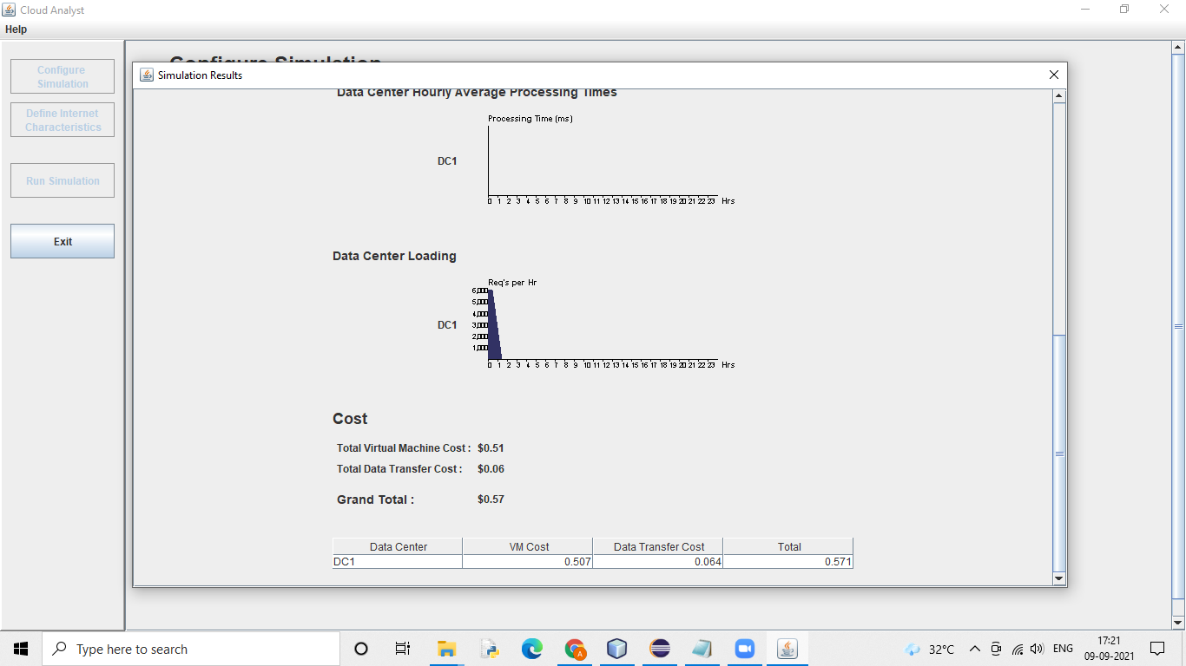

**We can see that it is working**